# Alzheimer’s Disease Detection Using MRI Scan

Tejavath Balakrishna Dr.Subba rao Kolavennu Computer Science Engineering Computer Science and Engineering

(JNTUH) (JNTUH)

Sphoorthy Engineering College Sphoorthy Engineering College Hyderabad, India Hyderabad, India

[balakrishna@sphoorthyEngg.ac.in](mailto:balakrishna@sphoorthyEngg.ac.in) [profrao99@gmail.com](mailto:profrao99@gmail.com)

|  |  |  |
| --- | --- | --- |
| G.Abhinav  Computer Science Engineering | J.Naveen kumar  Computer Science Engineering | k.Nikhil  Computer Science Engineering |
| (JNTUH) | (JNTUH) | (JNTUH) |
| Sphoorthy Engineering College | Sphoorthy Engineering College | Sphoorthy Engineering College |
| Hyderabad,India | Hyderabad, India | Hyderabad,India |
| [19n81a0598@gmail.com](mailto:19n81a0598@gmail.com) | [19N81A0596@gmail.com](mailto:19N81A0596@gmail.com) | ***kasulanikhil177@gmail.com*** |

|  |  |
| --- | --- |
| 1. ***ABSTRACT***   Alzheimer's disease is a progressive neurodegenerative disorder that primarily affects the elderly population, leading to cognitive decline and memory impairment. Early and accurate detection of Alzheimer's disease plays a crucial role in providing timely interventions and improving patient outcomes. Magnetic Resonance Imaging (MRI) scans have emerged as a powerful tool for assessing structural brain changes associated with Alzheimer's disease. This abstract presents an overview of an Alzheimer's Disease Detection system that utilizes MRI scans for early diagnosis and intervention. The proposed system leverages advanced image analysis techniques and machine learning algorithms to extract relevant features from MRI scans and classify them into Alzheimer's disease or non-Alzheimer's disease categories.  The workflow of the system involves preprocessing the MRI scans to enhance image quality and remove noise, followed by feature extraction to capture meaningful information related to brain structures and abnormalities. Machine learning algorithms, such as support vector machines (SVM), random forests, or deep learning models, are then trained on labeled MRI datasets to learn the patterns and characteristics specific to Alzheimer's disease. The results indicate the effectiveness and potential of the proposed system in accurately identifying individuals with Alzheimer's disease based on MRI scans  Keyword: Magnetic Resonance Imaging (MRI), support vector machines, deep learning models  ***INTRODUCTION-***  The manual interpretation of MRI scans for Alzheimer's disease diagnosis is a complex and time-consuming task that heavily relies on the expertise of trained radiologists | The subjective nature of visual interpretation can introduce variations and lead to diagnostic inaccuracies. Additionally, the growing number of MRI scans and the shortage of expert radiologists pose challenges for timely and widespread Alzheimer's disease detection. To address these challenges, there is a need for an automated and reliable system that can accurately detect Alzheimer's disease using MRI scans. Deep Learning, a subfield of machine learning, has shown remarkable potential in image analysis tasks. Leveraging the power of Deep Learning algorithms can help extract meaningful features from MRI scans and develop robust models capable of accurate Alzheimer's disease detection.  Therefore, the problem statement for this project is to design and develop an automated system that utilizes Deep Learning techniques to analyze MRI scans and accurately detect Alzheimer's disease. The system should be able to preprocess MRI  images, extract relevant features, train a Deep Learning model on labeled datasets, and provide reliable classification results. The developed system should demonstrate high accuracy, sensitivity, and specificity in Alzheimer's disease detection, while also being efficient, user-friendly, and scalable to handle large volumes of MRI data. |

# LITERATURE SURVEY-

We have surveyed the existing projects and finally thought of making necessary modifications for getting the latest edition.

VoxelNet: VoxelNet is a Deep Learning framework designed specifically for Alzheimer's disease detection using 3D voxel-based MRI scans. It employs a 3D CNN architecture to learn discriminative features directly from the voxel-level data and achieves promising results in early diagnosis.AD-DL: AD-DL is another Deep Learning-based system that combines multiple MRI modalities, including structural MRI and functional MRI, to improve Alzheimer's disease detection. It utilizes a combination of 3D CNN and Recurrent Neural Network (RNN) architectures to learn spatial and temporal features from MRI data.ADNI (Alzheimer's Disease Neuroimaging Initiative): ADNI is a large-scale research initiative that collects and shares MRI scan data, clinical information, and biomarker data for Alzheimer's disease research. It has facilitated the development and evaluation of various Deep Learning models for Alzheimer's disease detection.

# IMPLEMENTATION-

1. Data Collection:Obtain a dataset of MRI scans from individuals with diagnosed Alzheimer's disease and healthy controls. Ensure the dataset includes relevant demographic and clinical information.

2. Preprocessing: Perform preprocessing steps on the MRI scans, including skull stripping, spatial normalization, intensity normalization, and noise reduction. Apply quality control measures to ensure the consistency and reliability of the data.

3. Data Augmentation (Optional): Apply data augmentation techniques to increase the diversity of the dataset, such as rotation, scaling, flipping, and elastic deformation. This step can help improve the robustness and generalization of the deep learning model.

4. Model selection:Choose an appropriate deep learning architecture for Alzhemiers’s disease detection using mri scans, such as a Convolutional neural network (CNN) using

Preexisting architectures like RestNet ,DenseNet or design a custom architecture specifically tailored to the task.

5. Model Development:Split the dataset into training, validation, and testing sets. Ensure a balanced distribution of samples across classes.Train the deep learning model on the training set using the MRI scans and associated labels (AD or healthy).Optimize the model hyperparameters, such as learning rate, batch size, and regularization techniques, to achieve optimal performance.

6. Model Evaluation:Evaluate the trained model on the validation set to monitor its performance and make necessary adjustments.Measure various evaluation metrics, including accuracy, precision, recall, F1-score, and area under the receiver operating characteristic curve (AUC-ROC).

.

7.Model Testing and Validation:Evaluate the final trained model on the testing set to assess its generalization performance.Validate the model on an independent external dataset, if available, to further evaluate its robustness and generalizability.

8. Interpretation and Visualization:Employ interpretability techniques, such as attention mechanisms or visualization methods, to identify the regions in MRI scans that contribute most to the AD classification.Generate visualizations, heatmaps, or saliency maps to provide insights into the model's decision-making process.

9. Performance Comparison and Validation:Compare the performance of the developed model with existing methods or benchmarks to assess its effectiveness.Validate the model's performance on larger and diverse datasets to ensure its reliability and generalizability.

10. Deployment and Clinical Integration:Integrate the trained deep learning model into a user-friendly interface or a clinical decision support system for real-world applications.Collaborate with healthcare professionals and experts to validate the model's clinical relevance and usability.

11. Continuous Improvement:Update and refine the model periodically as new data becomes available or as advancements in deep learning techniques occur.Stay updated with the latest research and incorporate new findings to enhance the model's performance and applicability.

It's important to note that implementing the project requires proficiency in programming languages such as Python and familiarity with deep learning frameworks like TensorFlow or PyTorch for CNN implementation. Additionally, you will need knowledge of machine learning libraries like scikit-learn for Random Forest implementation.

# Results-

* 1. Sample Dataset Used

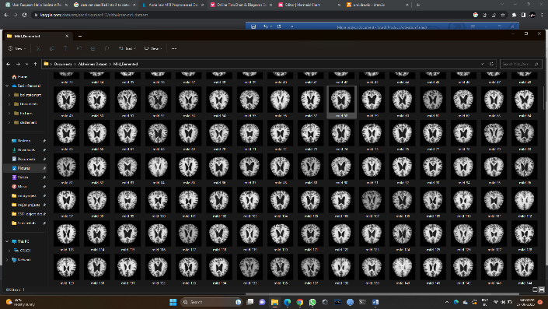

Fig 1. MRI scan Dataset

training and testing sets.

5.3 Train CNN with dataset

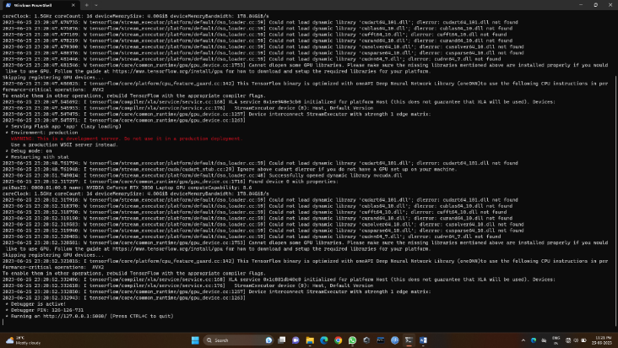

Fig3.In above screen with normal CNN we generated the webpage link.

Fig 5.4 Train CNN with Random Forest.

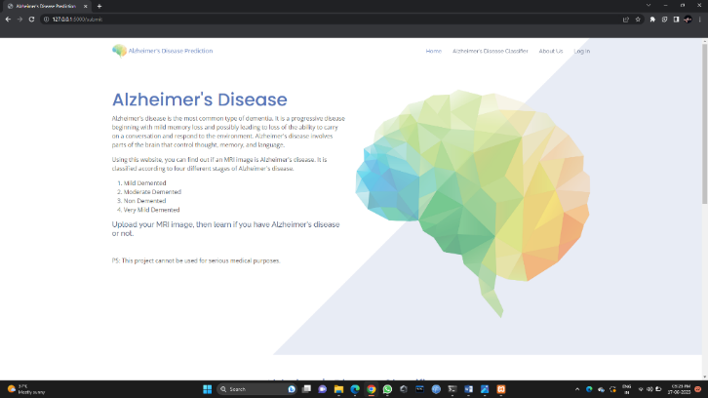

Fig4. In above screen , the Alzheimer’s disease detection webpage appears.

* 1. Pre-Processing.

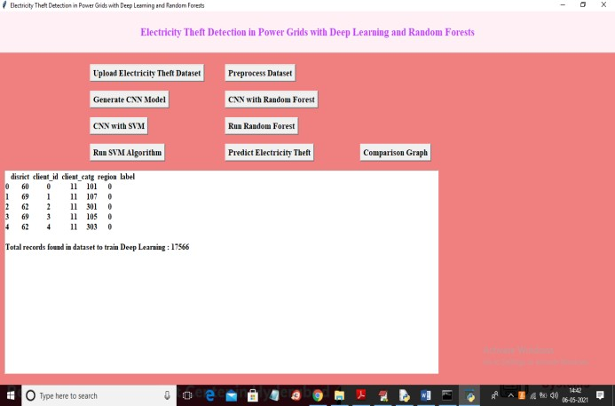

Fig.2 In above screen dataset loaded and displaying few records from dataset and this records contains non-numeric values and this values will not accept by machine

Fig 5.6 Train Random forest without SVM

Fig 6. In above screen with alone Random Forest we got 94% accuracy and now click on ‘Run SVM Algorithm’ button to train alone SVM with above dataset

Fig 5.7 Train SVM without CNN

Fig 5. In above screen with CNN-SVM we got 99% accuracy and now click on ‘Run Random Forest’ button to train alone RF on dataset

5.9 Comparison Graph

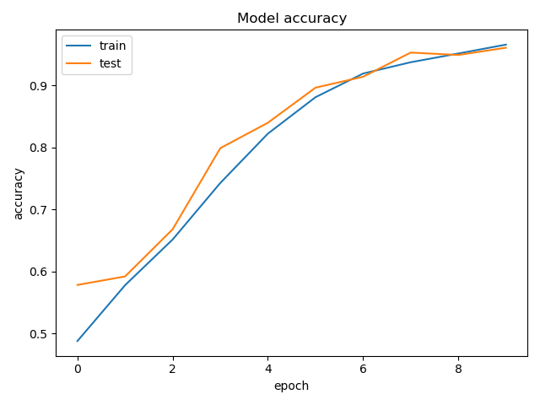

Fig 9 In above graph refers to the performance metric that measures the proportion of correct predictions made by a model out of the total number of predictions.

# CONCLUSION-

Alzheimer's disease detection using MRI scans and deep learning techniques holds significant promise for early and accurate diagnosis. This literature survey has highlighted the potential of combining MRI data with deep learning models to improve the detection and classification of Alzheimer's disease.Deep learning architectures, such as convolutional neural networks (CNNs) and 3D CNNs, have demonstrated their ability to automatically learn and extract features from MRI scans, enabling the identification of AD-related patterns and structural changes in the brain. These models have shown promising results in differentiating between individuals with Alzheimer's disease and healthy controls.The integration of deep learning with MRI scans allows for a more objective and efficient analysis of brain images, reducing the dependence on manual assessments and potentially enabling earlier detection of Alzheimer's disease. Moreover, the fusion of MRI scans with other imaging modalities or clinical and demographic data has shown potential in enhancing the accuracy and robustness of AD detection models.However, it is important to acknowledge that further research and development are necessary to overcome certain challenges. These include the need for larger and diverse datasets to improve model generalization, the interpretability and explainability of deep learning models, and the validation of developed models on external datasets and in real-world clinical settings.Despite these challenges, the combination of MRI scans and deep learning techniques represents a promising approach for Alzheimer's disease detection.

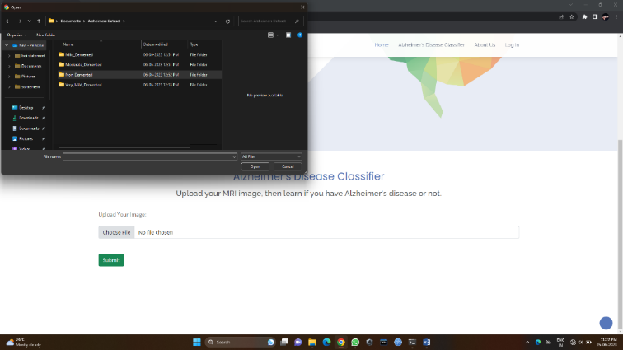

Fig 7. In above screen the user inputs the mri scan.

Fig 5.User input MRI ,get Prediction Result.

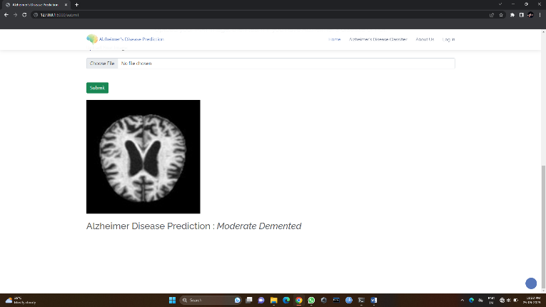

Fig8. In the above screen results the Alzheimer’s disease existence.

# ACKNOWLEDGEMENT-

This work has been carried out as part of our academic project to be submitted to the university. In this project work, we got the guidance and all inputs from our internal guide Mr. Tejavath BalaKrishna and we are thankful to our guide for his constant support and encouragement without which, the paper could not be completed.

# REFERENCES-

1.Knopman DS, Amieva H, Petersen RC, et al. (May 2022). "Alzheimer disease". Nat Rev Dis Primers. 7 (1): 33. doi:10.1038/s41572-021-00269-y. PMC 8574196. PMID 33986301.

2."Dementia Fact sheet". World Health Organization. September 2022.

3.Ganguli M, Dodge HH, Shen C, Pandav RS, DeKosky ST (May 2021). "Alzheimer disease and mortality: a 15-year epidemiological study". Archives of Neurology. 62 (5): 779–784. doi:10.1001/archneur.62.5.779. PMID 15883266.